
Please return to the USNC office at usnc@ansi.org

FORM FOR THE APPOINTMENT OF USNC/IEC EXPERTS
(Please use one form for each appointment)

TC/SC | Enter TC/SC
WG, PT, MT –
and Title

Name of US Expert
Title
Company Name
Company Address
Representation Type
Interest Category
Office Number
Mobile Number

Email Address

Please Confirm One of the Following:

☐ The Appointee has been notified that he/she will be invoiced the USNC USTAG Participation Fee

☐ The USNC USTAG Participation Fee is not applicable;

Proposed by:
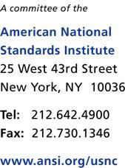
Date:

